Start new C++ basic project

Copy assets to content folder

Create a pawn C++ class called PacmanPawn

Add following code to PacmanPawn.h file

protected:

UPROPERTY(BlueprintReadOnly)

bool Frozen = true;

public:

void SetDirection(const FVector Direction);

bool IsFrozen() { return Frozen; }

UFUNCTION(BlueprintCallable)

void SetFrozen(bool Value) { Frozen = Value; }

private:

UFUNCTION()

void OnOverlapBegin(AActor* PlyaerActor, AActor* OtherActor);

Create a Blueprint folder

Create a BP version of the PacmanPawn

Add 2 components

* + Floating Pawn Movement
  + Static mesh Sphere

Give pacman material for sphere and make sphere the default root.

Scale sphere to 0.5

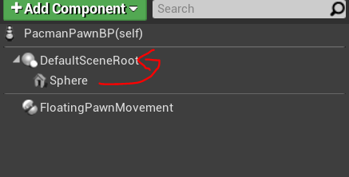

Add another static mesh and name it pacman

Select pacman static mesh from details panel

Change scale to 1.5

Set visibility hidden for the root sphere

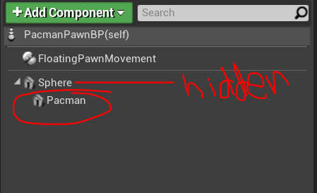

Place the pacman in level to see the scale is right.

Level can be found in Content\Pacman\Levels

When we play we will not be able to see the whole game.

To fix do the following.

Add a custom event called “SetupCamera” and add the following BP

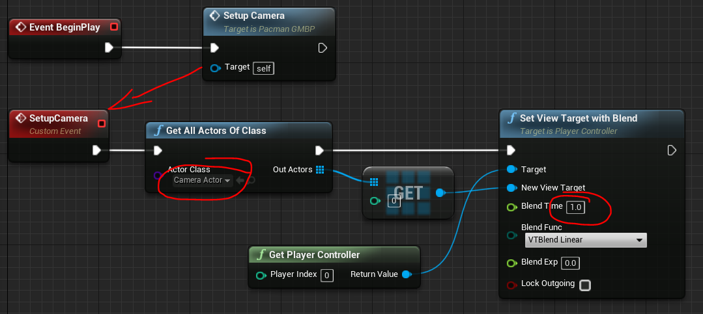

In the project settings make the following changes

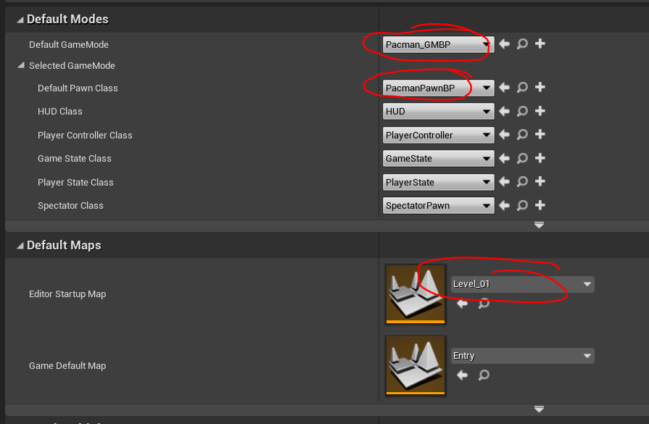

When we start the game we should see the whole level.

Now add following code to begin play of Pawn

OnActorBeginOverlap.AddDynamic(this, &APacmanPawn::OnOverlapBegin);

Add following to Tick

if (!Frozen) {

AddMovementInput(GetActorForwardVector());

}

Add following to set Direction method

if (Direction == FVector::UpVector) {

SetActorRotation(FRotator(0.0f, 270.0f, 0.0f));

}

else if (Direction == FVector::DownVector) {

SetActorRotation(FRotator(0.0f, 90.0f, 0.0f));

}

else if (Direction == FVector::RightVector) {

SetActorRotation(FRotator(0.0f, 0.0f, 0.0f));

}

else if (Direction == FVector::LeftVector) {

SetActorRotation(FRotator(0.0f, 180.0f, 180.0f));

}

Now we need to create a controller.

So in the editor create a C++ Player Controller called PacmanController

Add following code to header file.

protected:

void SetupInputComponent() override;

APacmanPawn* GetPacmanPawn() const;

public:

void MoveUp();

void MoveDown();

void MoveRight();

void MoveLeft();

forward decleration required

class APacmanPawn;

create definition for all methods in the CPP file

Change definition of GetPacmanPawn as following

APacmanPawn* APacmanController::GetPacmanPawn() const

{

return Cast<APacmanPawn>(GetPawn());

}

And input binding as following.

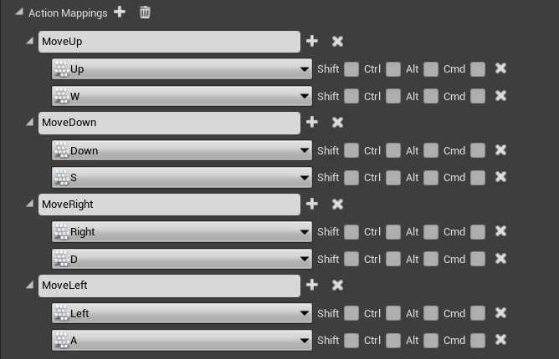

Add the following code to SetupInputComponent method

Super::SetupInputComponent(); //Dont mind the error line below SetupInputComponent

InputComponent->BindAction("MoveUp", IE_Pressed, this, &APacmanController::MoveUp);

InputComponent->BindAction("MoveDown", IE_Pressed, this, &APacmanController::MoveDown);

InputComponent->BindAction("MoveLeft", IE_Pressed, this, &APacmanController::MoveLeft);

InputComponent->BindAction("MoveRight", IE_Pressed, this, &APacmanController::MoveRight);

Change the move methods as following

void APacmanController::MoveUp()

{

if (GetPacmanPawn() != nullptr) {

GetPacmanPawn()->SetDirection(FVector::UpVector);

}

}

void APacmanController::MoveDown()

{

if (GetPacmanPawn() != nullptr) {

GetPacmanPawn()->SetDirection(FVector::DownVector);

}

}

void APacmanController::MoveRight()

{

if (GetPacmanPawn() != nullptr) {

GetPacmanPawn()->SetDirection(FVector::RightVector);

}

}

void APacmanController::MoveLeft()

{

if (GetPacmanPawn() != nullptr) {

GetPacmanPawn()->SetDirection(FVector::LeftVector);

}

}

Change the player controller to PacmanController in the project settings

Pacman should be able to turn but not move.

Change the begin play of GameModeBP as follows

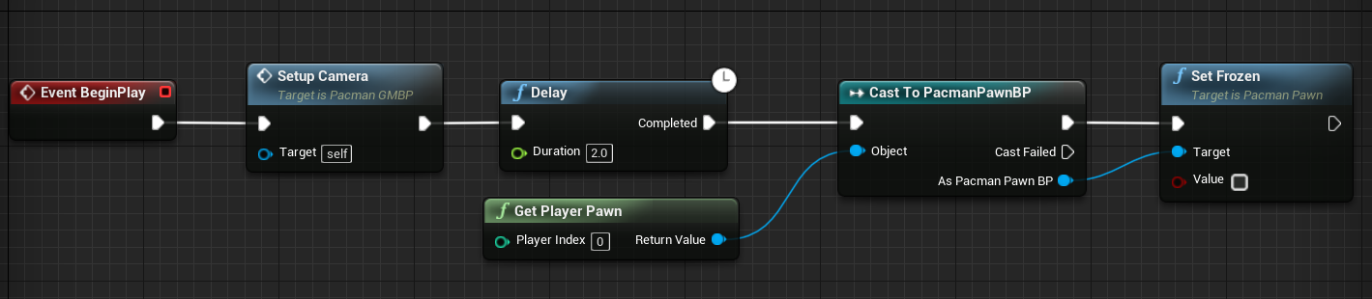

Now pacman should be able to move.

If it penetrates through wall adjust the size of sphere and pacman in pacmanpawn.

Make following changes in FloatingPawnMovement.

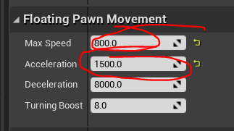

Create a C++ actor class called Food.

In the Header just after includes add the following

UENUM(BlueprintType)

enum class EFoodType : uint8 {

Regular,

PowerUp

};

DECLARE_DYNAMIC_DELEGATE_OneParam(FFoodEatenEvent, EFoodType, FoodType);

To do from 3:24:31

https://youtu.be/LsNW4FPHuZE?t=12271